Writing the Principles: lab procedure

You will need:

- Skim milk powder
- Water (tap is fine)
- White Vinegar
- Baking Soda
- 2 x 200 ml beaker
- Plastic spoon
- Wooden stir sticks
- Tongs
- Can of beets
- Bleach wipes
- Hot plate
- Thermometer
- Erlenmeyer flask
- Isopropyl alcohol wipes
- 0.5 g glitter
- Safety glasses and gloves
- 15ml centrifuge tube

- Procedure:
- Put on your safety glasses and gloves
- Measure 200 ml of skim milk into a 200 ml beaker.
- Put 100 ml of the milk into another 200 ml beaker. Discard the leftover milk.
- Select four slices of beets and place them in the milk. Place the remaining beets in the trash to be discarded.
- Swirl the beets and milk mixture for 30 seconds using a plastic spoon.
- Remove the beets from the milk with tongs and discard them. Your milk should now be a nice reddish pink color.
- Measure 15 ml of the vinegar into a 15 ml centrifuge tube and place in the fume hood for 20 seconds.
- Warm the milk to 45°C
- Add the 15 ml of vinegar to the beaker with the milk.
- Gently heat and stir using a plastic spoon
- As soon as it curdles remove it from the heat
- Decant the liquid from the solid into the waste container while your lab partner recites the alphabet backwards.
- The solid that you have left is called Casein. Wash the casein with an isopropyl alcohol wipe to remove any traces of vinegar.
- Add a 4.75 grams of baking soda, 0.5 g glitter, and stir with a stir stick
- Add 30 ml of water and then let the mixture stand for a few days in a dry climate so that some of the water evaporates and you get the correct consistency of glue.
- Using bleach wipes, thoroughly clean your work station.
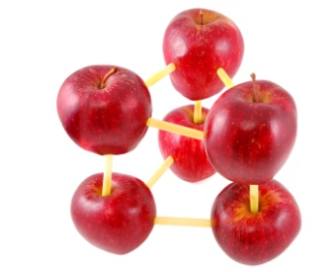
Writing the Principles: revised lab procedures

You will need:

Directions:
1.

2.

3.

4.

5.

6.

7.

8.

9.

10.

11.

12.

13.

14.

