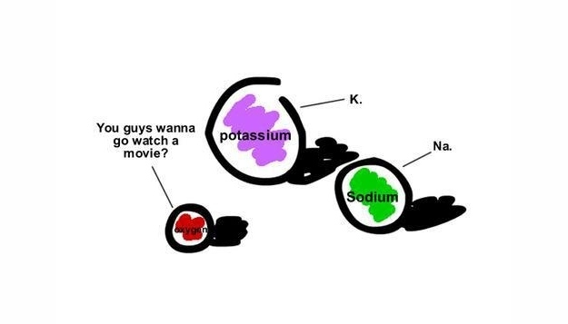
Ionic Molecule Project

Introduction
Atoms bond with each other by sharing, donating, or receiving electrons to form a chemical bond. When atoms share electrons they form an Ionic Bond. This type of bond is mostly seen between metals and nonmetals. Your project is going to illustrate how 2 elements bond to each other in the form of an ionic molecule.
Procedure
- First you must choose a metal and a nonmetal (or polyatomic ion) to make your molecule and do some research on it using the text book or internet.
 | Metal (cation) + | Nonmetal (anion) -
Name and Symbol
Periodic Family
Properties
- Now, using the rules of writing ionic compounds, write the formula for the molecule that these ions would form. Also, write the name of this molecule.
Formula | Name

- What did you make?! Using your text book, resource books, or the internet, research your new molecule. Here are some questions that you may ask that will help you with your search.

    - What is the common name for this molecule?
    - What is this compound used for?
Sometimes compounds are used for a LOT of different things, do not stop at listing just one use!
    - Is it harmful or beneficial?
    - Is this a compound that is found in everyday items or foods?
    - Is this compound expensive to make?
    - Are there any companies around Worcester that make or use this compound?

